

CoPhilot

Example of a simple Agent architecture pattern

Author: Nico Sprotti – nicosprotti@microsoft,com
Date: November 2024

Contents
Purpose of the document 3
Deploying Llama 3.1 and Phi 3 in Azure AI Studio 4
Setting up the solution 5
Defining the environment variables 6
Creating the data model 7
The Conversation table 8
The Message table 9
Setting up the relationship between the two tables 10
Creating views and forms 11
The Message table view 11
The Message table Form 11
The Conversation View 12
The Conversation Form 13
Creating the model driven app 14
Creating the bot in Copilot Studio 15
Conversational orchestration engine 16
The Conversation Start topic 17
The Reset Conversation topic 18
Calling Power Automate to create a new Conversation 20
The fallback topic 21
Calling Power Automate to create a new user or assistant Message 22
Calling Power Automate to chat with the model 24
Adding custom topics 30
New conversation 30
Switching models 31
Viewing and updating dynamically the system prompt 32

Purpose of the document
Describe the architecture of a simple bot in Teams where users can chat with open-source models Llama 3.1 and Phi 3, leveraging only GA features as of Nov 2025.
The goal for the reader is to learn by building a useful and re-usable Power Platform solution while hitting on some core concepts of the Power Platform.
The solution is simple and includes 2 tables, 1 app, 2 custom topics and 3 Power Automate flows.
A live demo of this solution is accessible in our Power Platform Master Series.
Interview of this solution is on LinkedIn : Leveraging Copilot Studio to chat with Phi 3 and Llama 3.1 in Microsoft Teams | LinkedIn

Deploying Llama 3.1 and Phi 3 in Azure AI Studio
Azure AI Studio is pro code. Azure AI Studio is simple.
Azure AI Studio offers thousands of AI models, including frontier AI models available the “day of” the release. Many can be deployed as Model as a Service. For our example we deploy Llama 3.1 and Phi 3, which are leading open-source models in their own category.

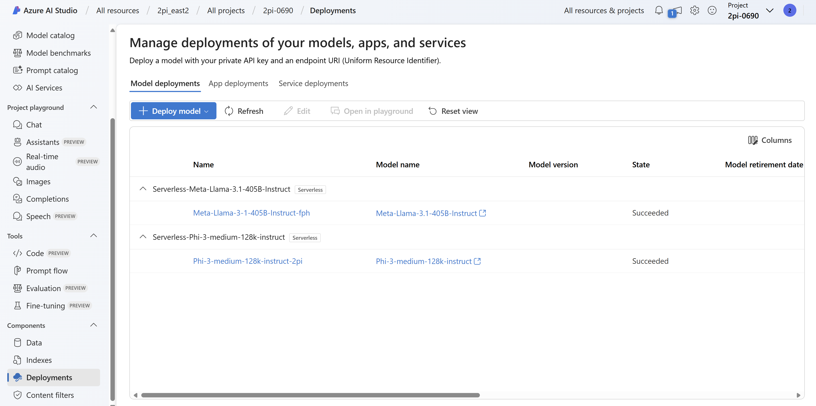

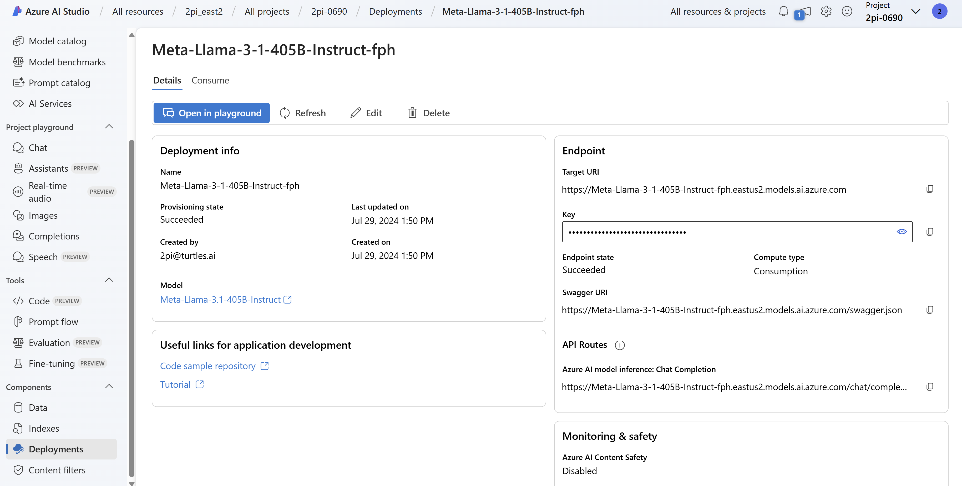

Setting up the solution
The solution in Power Platform is an important concept. It is more than a folder. It is structuring for the future ALM process. When well architected and governed, solutions allow us to decouple complexity and iterate faster.
A common pattern is the IT team building pro code custom connectors into legacy apps empowering their respective business partners (Power Platform coders or ‘makers’) to use such connectors in their solutions.

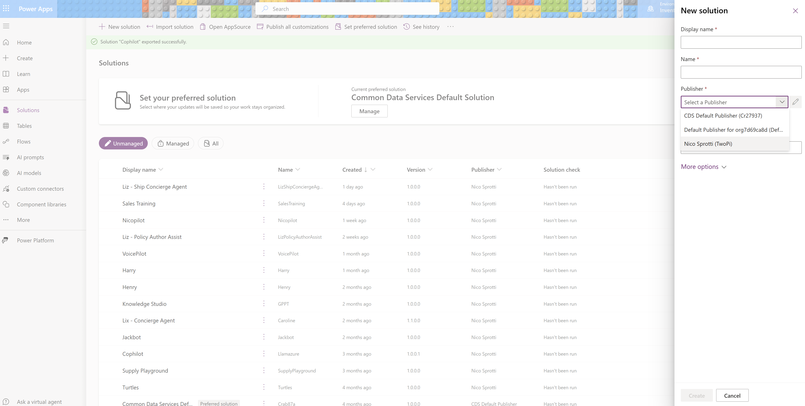

Defining the environment variables
Environment variables are defined at the solution level. They are usually variables that change during the ALM process but do not influence the business logic.
For our example all we need are four environments’ variables, Llama 3.1 end point and API key and Phi 3 end point and API key.
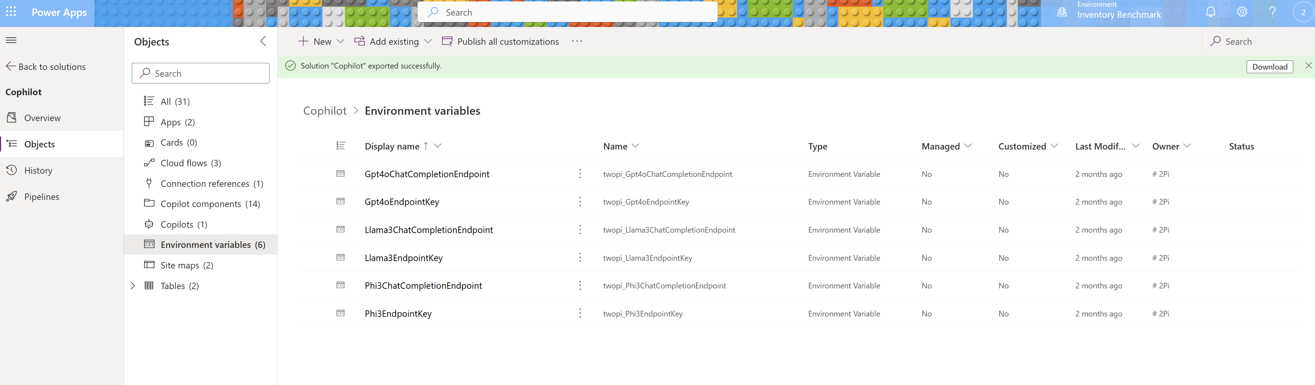

Creating the data model
The data model is often the hardest part of an elegant solution.
In our example we are using Dataverse to store, view, log, test and benchmark the conversations.
Out of the data model we built Model Driven apps, that are driven by the data model.
Those types of apps are very fast to build and iterate on. Always start there to prototype, we can always switch to a different database later should storage cost become a concern.
I find the hard part of data modeling is knowing which data to bring and where, so we don’t end up duplicating data across systems. It requires domain expertise to bring just the data we need to the right place to just solve our problem. In spirit, the less data we must bring, the less variables we must create, the better. I iterate my data models. During the prototyping phase, Power Platform is so fast that at times it is faster to restart from scratch vs iterating.
Model Driven Apps offer a robust ALM process. Model Driven apps have low TCO and scale securely fast.
All Microsoft Dynamics 365 CRM business applications suite are shipped as first party model driven apps. Dynamics 365 is a $6B Microsoft business unit and growing.
Dataverse encompasses a decade of engineering experience from Microsoft Business Application product team. With dataverse, we are sharing with everyone, Microsoft business application development platform.
Dataverse is all about how to securely scale fast while optimizing the engineering cost of my business application. At Microsoft we like to say we aim to do more with less, dataverse is a great example.
In its simplest form, I like to think of dataverse as Excel + Access + Security + Cloud + AI + Git + Governance +++

When we create a table, dataverse automatically create the core fields needed in all good business application data models (Create on, Created by, Modified on, Modified by …). Pay attention to the ‘name’ and ‘Id’ columns.
The tables below have been filtered to show only the added custom columns.

The Conversation table
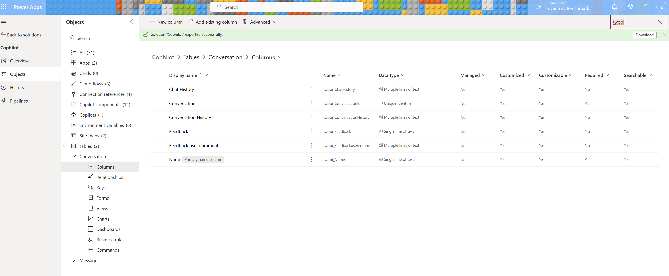

Conversation history: Contains the message table in an almost JSON ready to be parsed and sent to the model (just missing the system prompt).
This column is a performance trick, it is not to be displayed to the user. The trick is when we call the model we don’t have to loop over all the records in the message table for that conversation.
Make sure to create it as a multi-line text and expand the amount of text you can store in there. Same applies wherever we store long text.
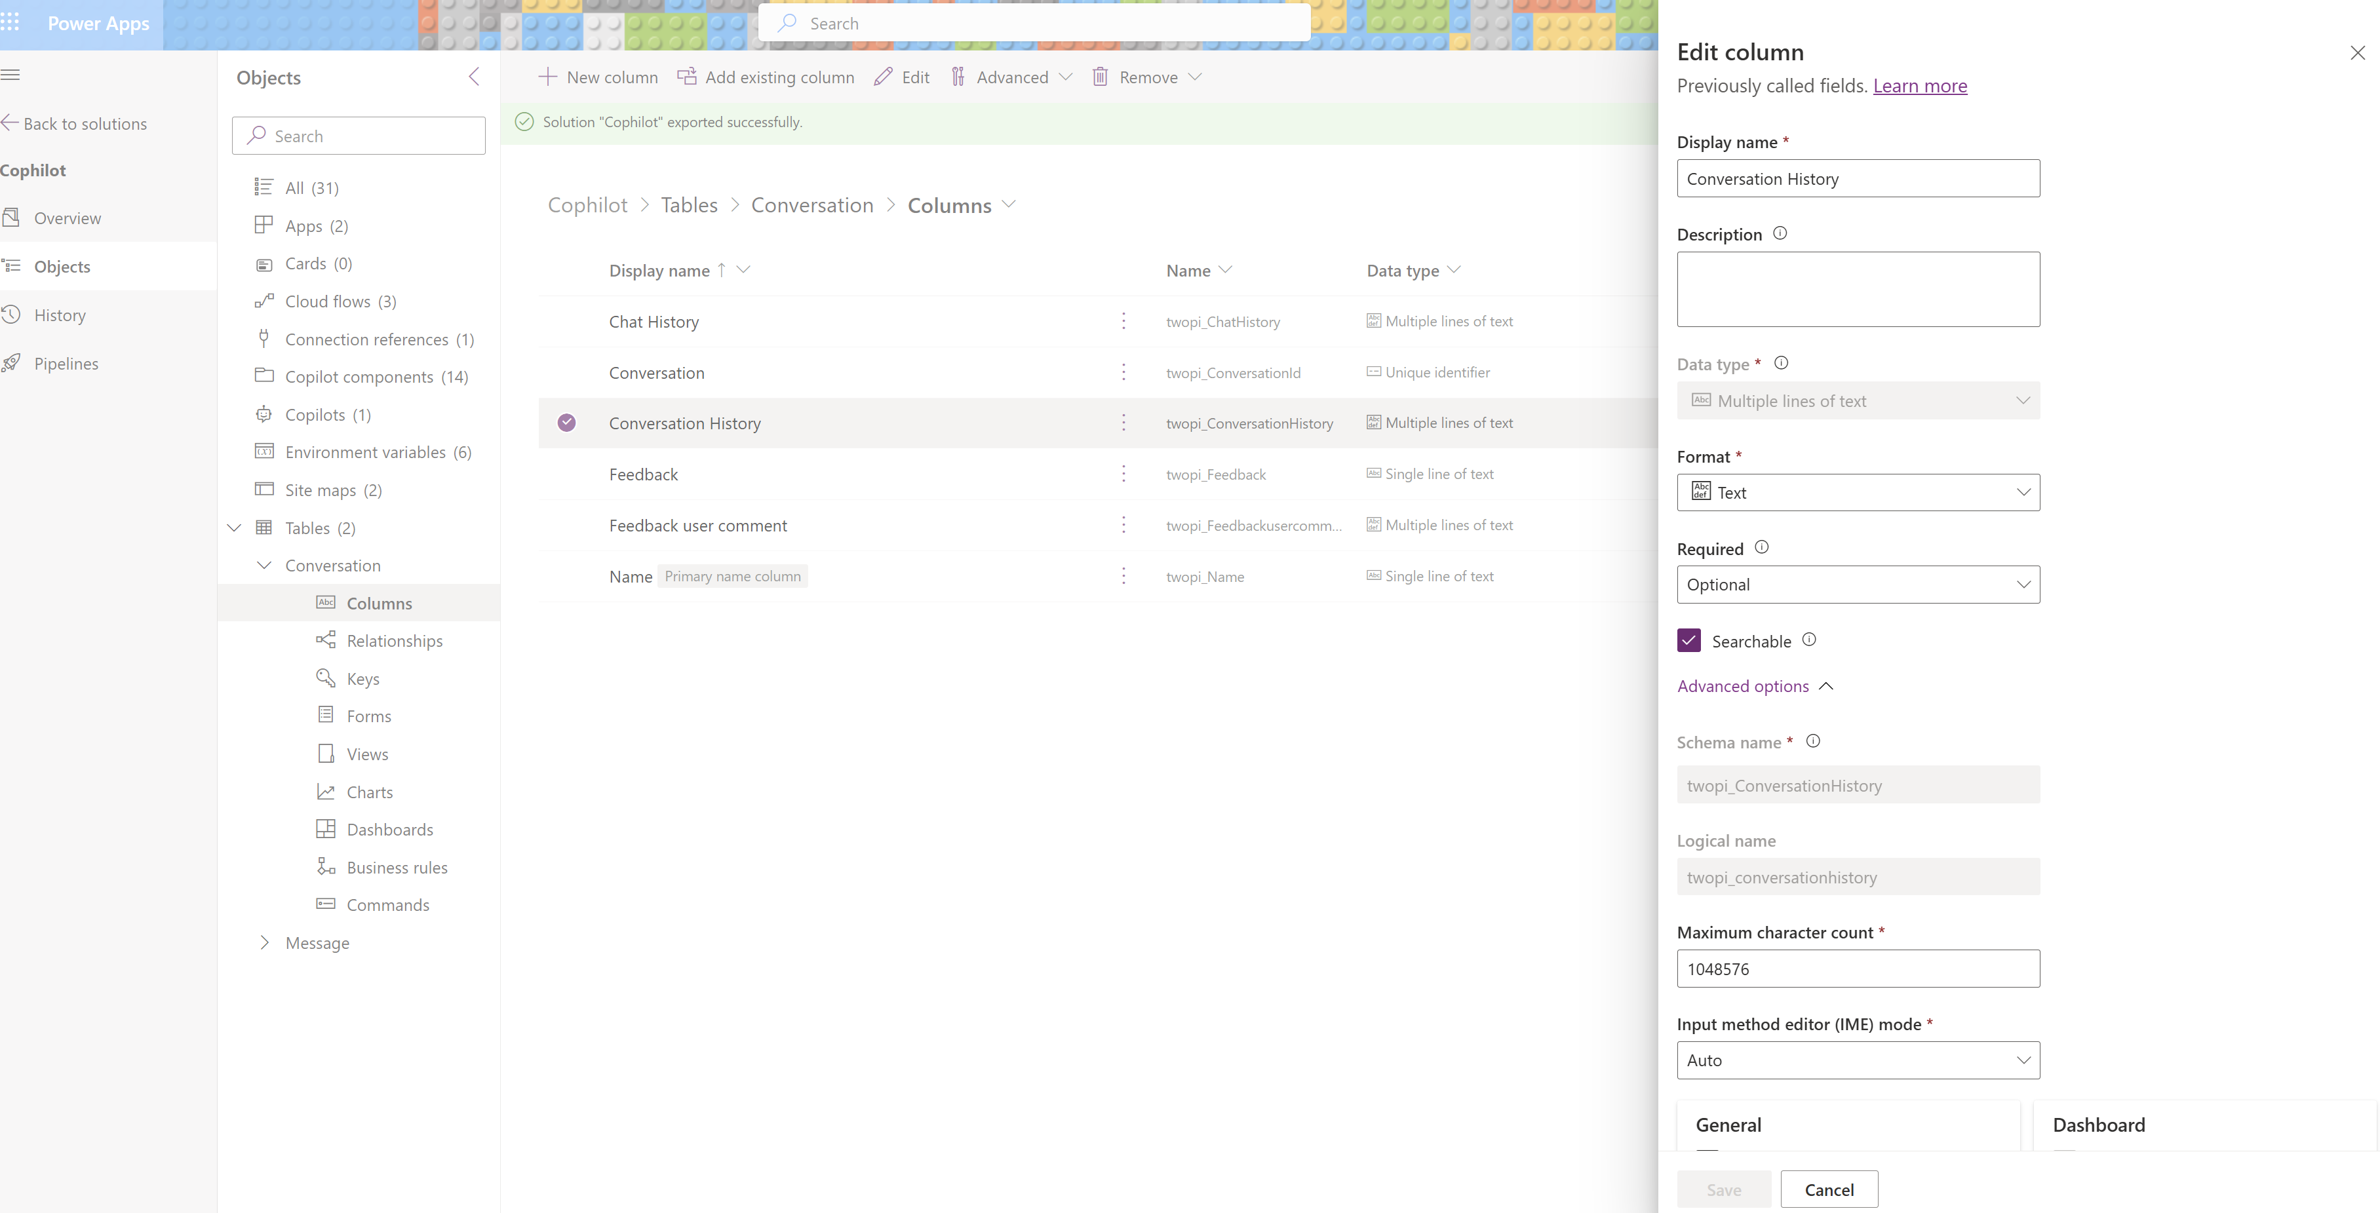

Chat history : Contains the actual chat of the conversation in a user readable format
Feedback / Feeback user comment : Optional, I add these columns to sometime help me capture a chat or an automation record I want to keep for future reference (especially when it fails).
Number of input / output token : Optional. I don’t have it here. The conversation or (automation) table is a great place to add a roll up sum of the token (or cost) per conversation.
Always remember we are prototyping, ready to fail and iterate fast.
I usually prototype first with gpt 4o calls everywhere, making it work with a no cost constraint spirit, value first mindset. If our prototype works and ends up having legs, explore cheaper SML options where it makes sense : Example of AI cost optimization with Phi.

The Message table
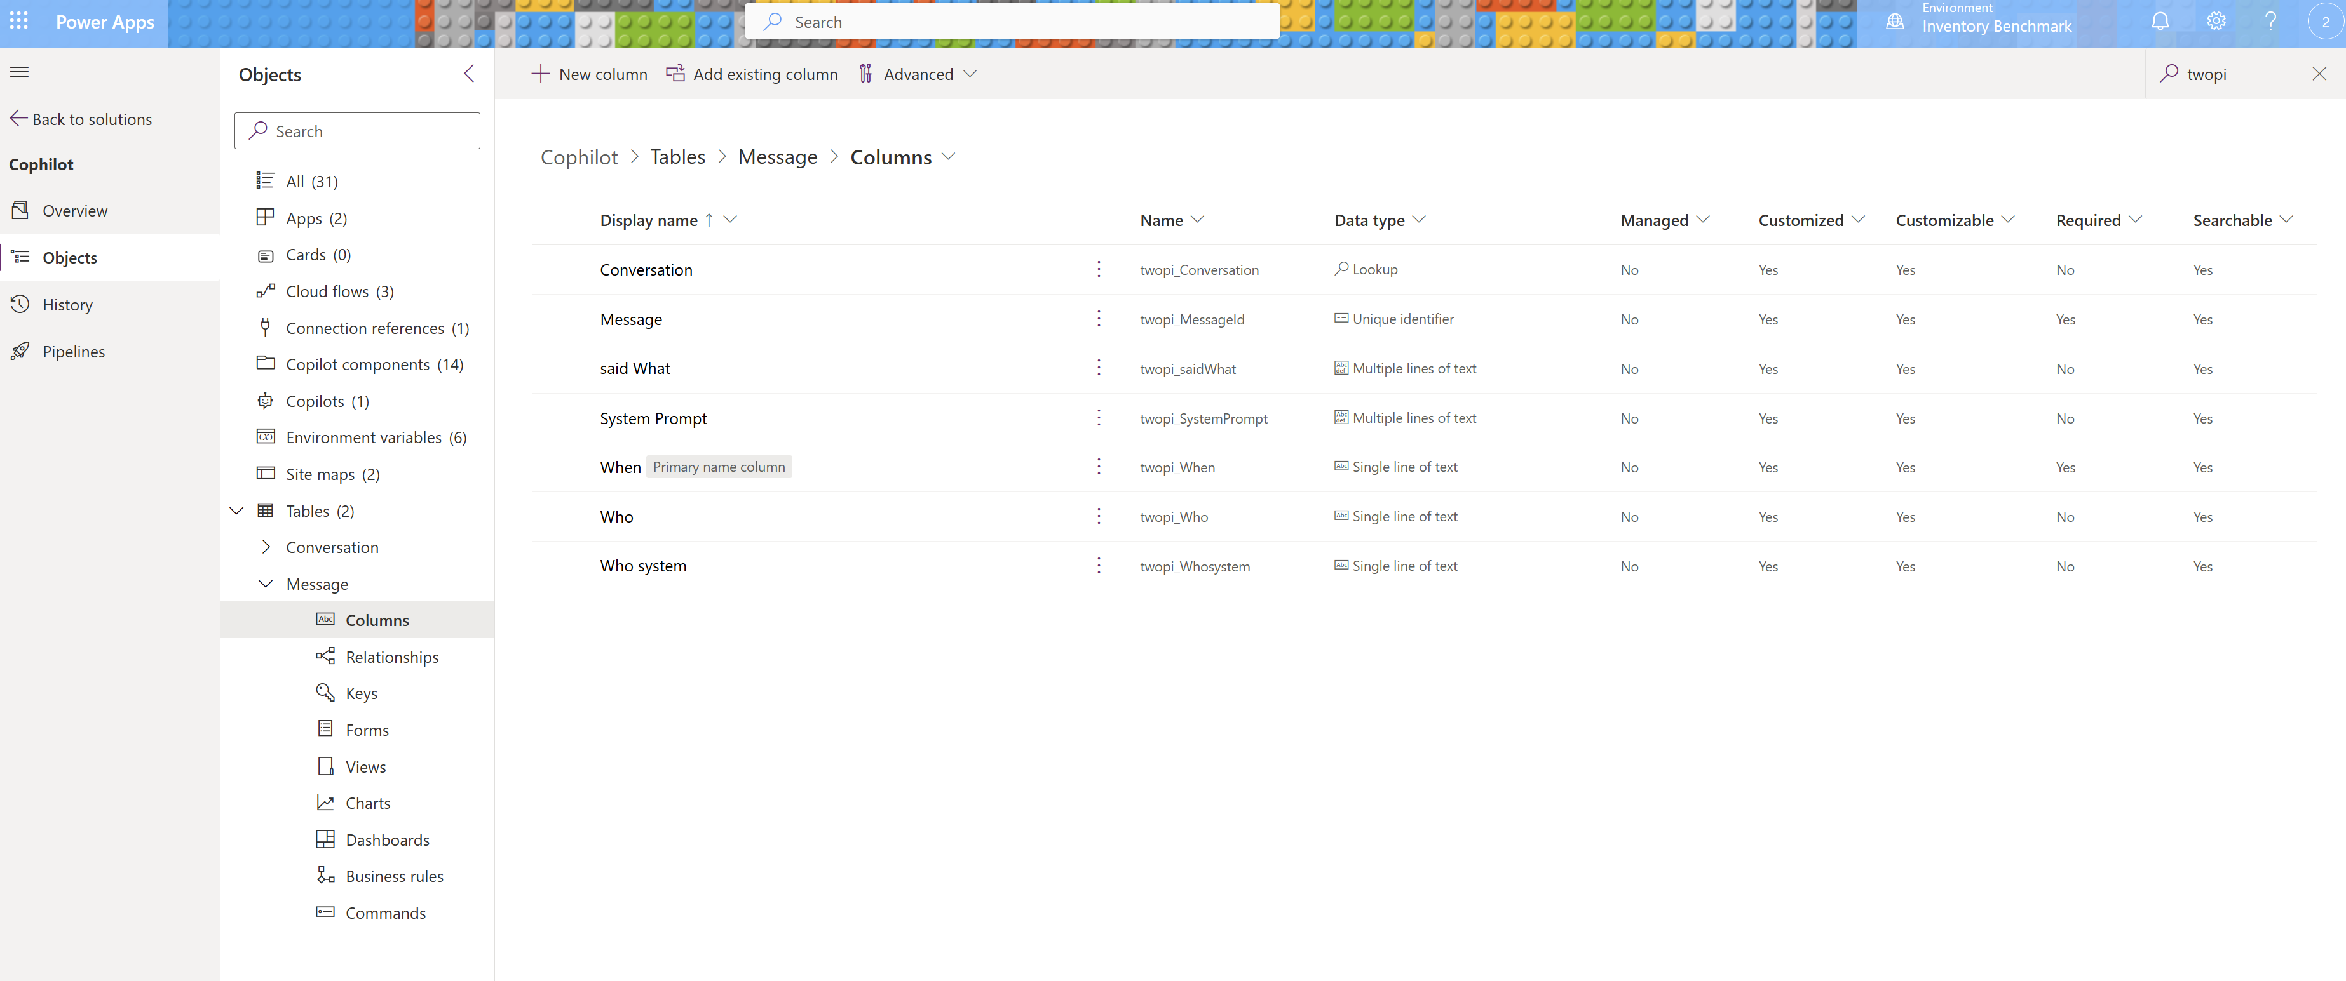
When : It is the primary column (usually called ‘name’ when you create the table) being renamed as ‘When’. We will store the date/time/sec in there that we will sort by.
Who system : It is either ‘user’ or ‘assistant’.
Who : The actual name of the user or the assistant
said What : What did the user or the assistant said
System Prompt : For assistant messages, it is the log of the system prompt used to generate the message (as we’ll be able to change the system prompt dynamically during the conversation).
Conversation : It is a lookup column pointing to our Conversation table (One conversation can have N messages)

Setting up the relationship between the two tables
When creating the lookup field to the Conversation table in the Message table, dataverse automatically creates a relationship between the two tables.
Make sure it is a Parental type of behavior relationship.
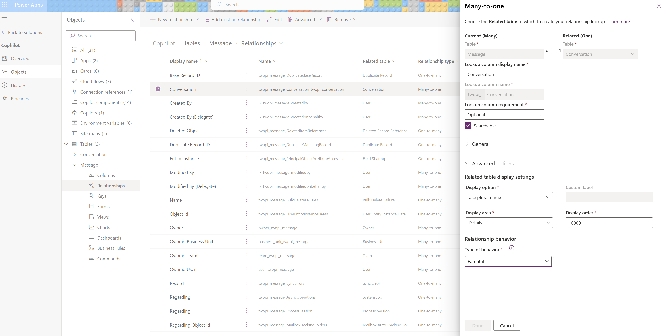

Creating views and forms
Views and Forms are the key elements after creating tables and relationships. Views are a subset of table data. Forms are used to edit a particular record in a table (A form can contain views of related lookup tables).
We start with the Message table as we’ll use the Message table view in the Conversation form.

The Message table view
We’ll use this message view in the Conversation Form. Do not forget to Save and publish.
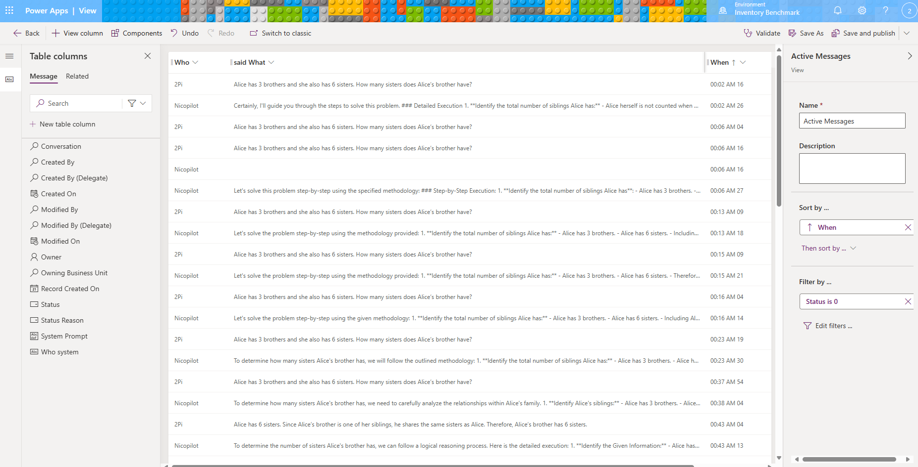

The Message table Form
In effect this form will only be used to dig into the log of the system prompt and cost of AI (if track at this level). Do not forget to Save and publish.
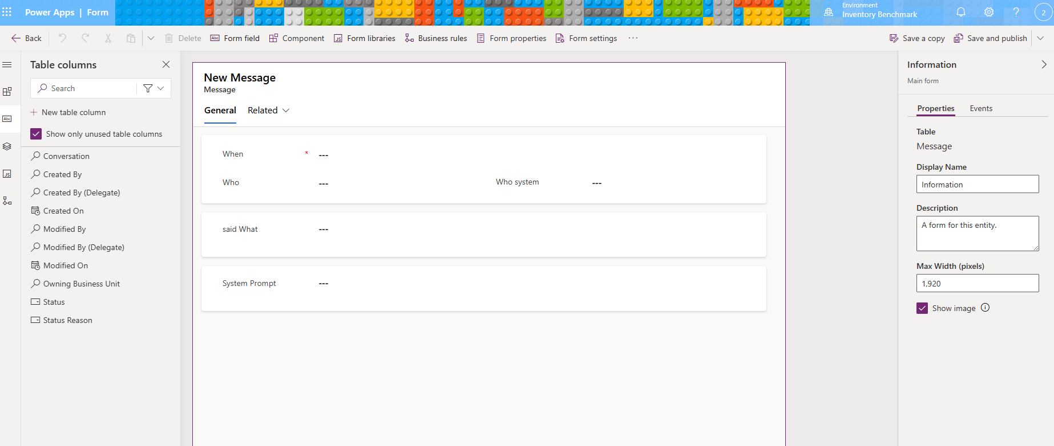

The Conversation View
This is the main view for the admin or users to access the history of the conversations.
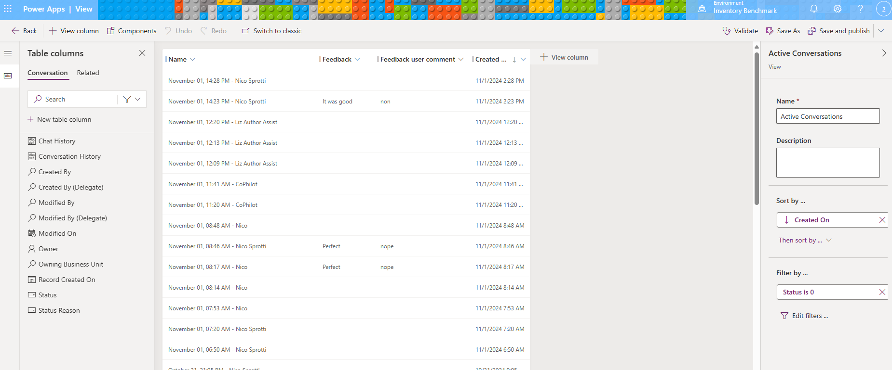

The Conversation Form
This is when the user (or admin) wants to drill down into a particular Conversation.
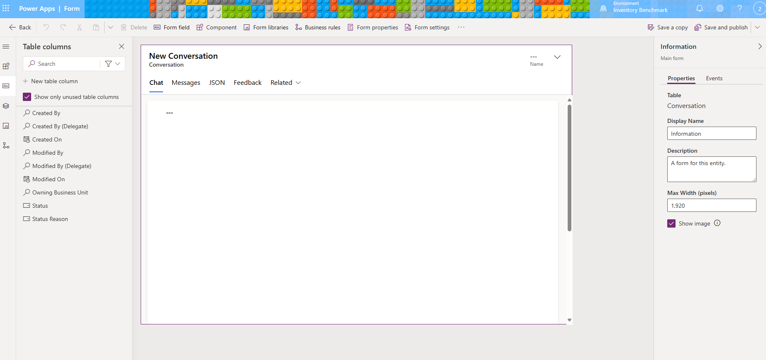

We renamed the ‘General’ Tab to Chat and just added the Chat History field in the section (without displaying the label).
In the Messages Tab newly created we display a sub grid of related data pointing to the messages table.
As we have set up a parental relationship, only the messages related to our conversation are displayed in the view.
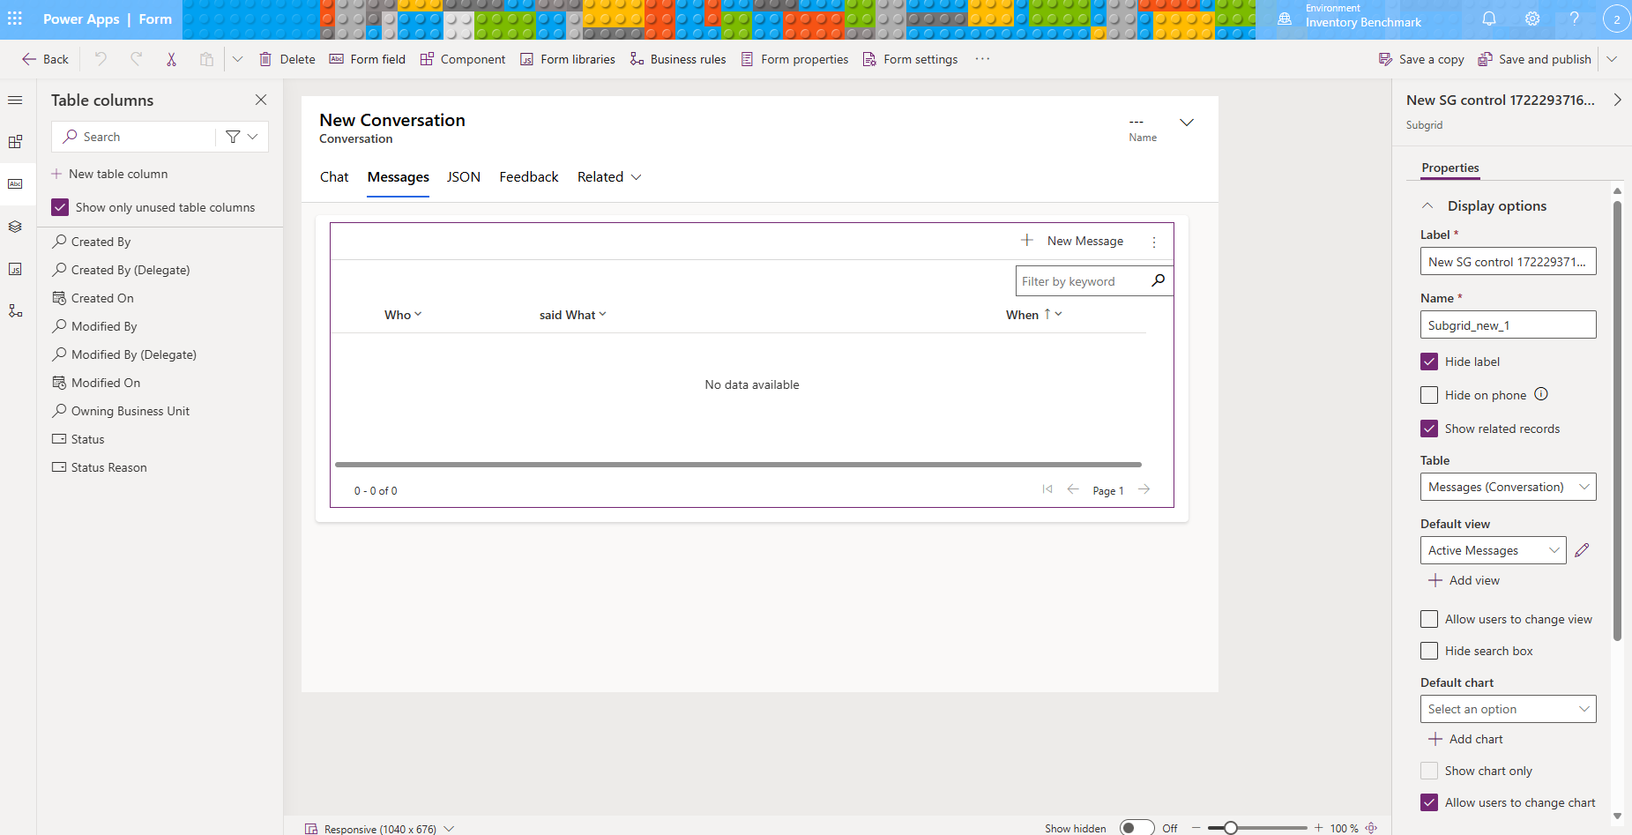

Creating the model driven app
Now we have our tables with the UX ready we can create the app. It is mainly about organizing the navigation, and which tables should be on the menu.
Do not forget to save and publish.
You can play the app from here to test it.
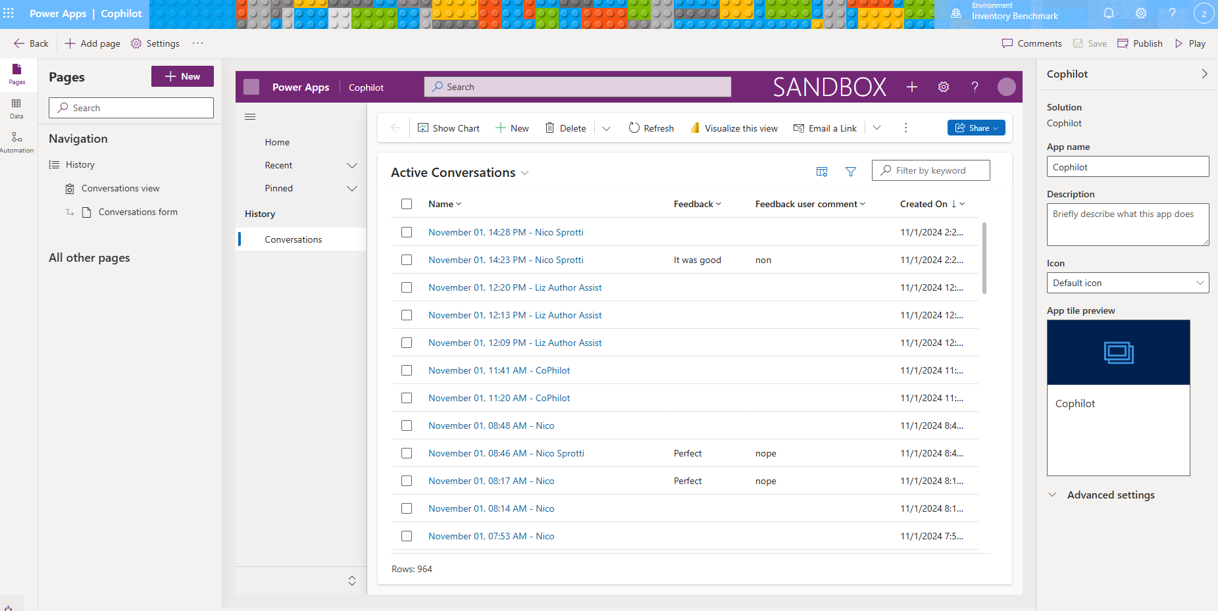

Creating the bot in Copilot Studio

This section is pure conversational UX design. I personally find it practical to build the bot unfolding linearly the conversation. I like to think of it as designing “chat wireframes”.
First, make sure to create the bot (agent) in the proper solution.
Once the agent (bot) gets created it comes with examples of custom topics. I usually start by deleting them all. We can’t delete system topics. I turn off the ones I am not planning on using. It keeps things cleaner.

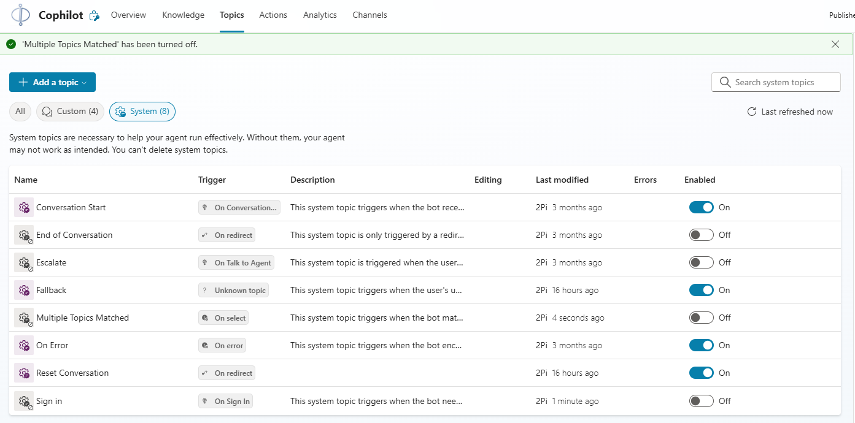

Conversational orchestration engine
Deciding on the conversation engine is a structuring decision in the bot design. You can change it as you iterate on the agent.
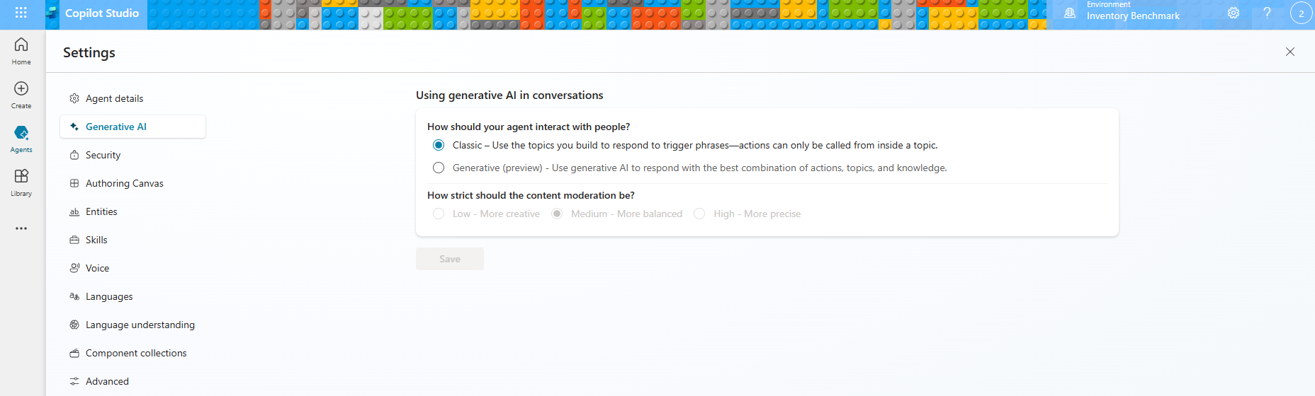
The Generative orchestration is Microsoft novel conversation engine leveraging generative AI to detect topics and actions that needs to be launched (example : if the user says, “I want to eat sushi”, the orchestration understand we need to trigger a topic for restaurant reservations without the need to have a trigger phrase saying “Eat sushi”).
It is essentially using function calling for the conversation orchestrator. It aims to simplify drastically bot authoring and offer more fluid conversations with the user. Today it is in preview, it is free to use but not ready for production. Product team is working hard to make it GA. It will most likely have an additional cost every time it orchestrates to a particular topic or action.

Classic is the classic orchestration Conversational UX engine. It detects topic based on triggered phrases (and more). It works, it is GA, it is in production at scale all over the world.

I suggest starting with the classic engine, first it is GA and you will appreciate and design better with the new conversion engine later. With the bot architecture pattern we are building here, there are plenty other places where it makes sense to inject GenAI first. With this architecture we also could make our own little orchestration engine if we need to.

The Conversation Start topic
The first topic that triggers in the bot is the Conversation Start topic. It is a system topic (you can’t delete it) that you can and should author.
When deploying the bot in Teams, it only triggers once when the user installs the bot. Think of Teams channel as an infinite conversation from an orchestration perspective.
In our example, we’ll be surfacing in Teams, that is why we are not putting business logic in there.
All we do is redirect the Conversation Starter topic to the Reset Conversation topic.

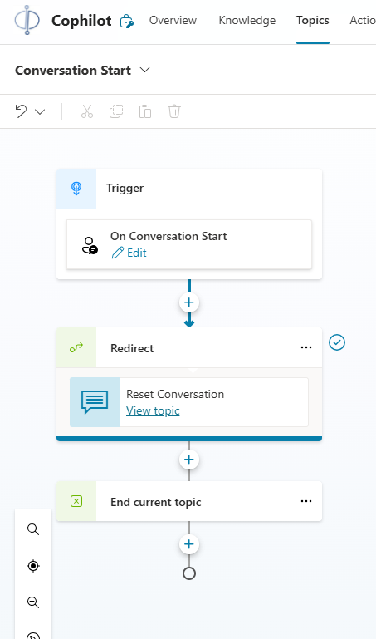

The Reset Conversation topic
This topic is called every time the user wants to have a new conversation with the model.
We first launched a Power Automate flow, detailed in the next section, to create a new conversation in our Conversation Dataverse table and return as a front-end variable the internal id of the newly created conversation that we display for debugging in the chat.
Make the ConversationId variable a global variable as we’ll carry it across topic.
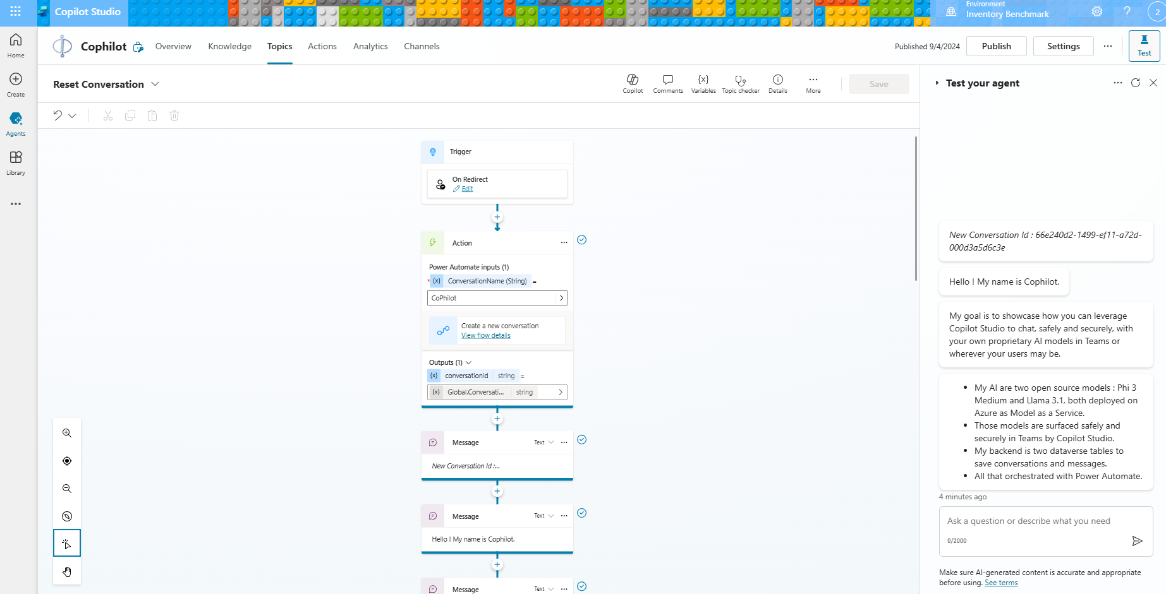

Now we have our conversation created, it is good place to script whatever introduction message to the user.

Now we have the conversation with the other global variables we’ll need to call our model are the system prompt and API endpoint and keys. We use the environment variables previously created to initialize them with Phi 3 endpoint and key.
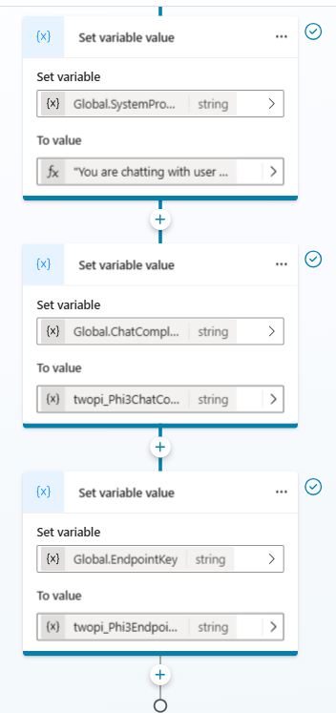
As an example here is the system prompt I am using in this agent (bot) :
"You are chatting with the user in MS Teams.
Your name is CoPhilot. It is a silly play with Microsoft 'Phi' Small Language Model and Microsoft 'Copilot Studio' the chat orchestration solution.
You are the technology proof data science teams can bring their own Azure AI model in Copilot Studio so everyone can chat with it safely and securely in Teams like we are doing now.
Your architecture is Phi 3 deployed as a Model as a Service on Azure AI and surfaced here in Teams by Copilot Studio.
Your actual goal is to help the user with whatever they ask."

Calling Power Automate to create a new Conversation
In the context of Copilot Studio, I like to think of Power Automate as the gate between frontend and backend development. Almost like my Power Automate flows are equivalent to an API call I can design. When call from Copilot Studio Power Automate premium connectors are entitled. In essence, it makes Power Automate a great feature of Copilot Studio for prototyping.
It is important to note that Power Automate is an event driven architecture. Even if the calls from Copilot Studio feel real time it is asynchronous. Copilot Studio also offers other options to true real time API calls like when using the send HTTP request node.
When prototyping I always start with Power Automate as it helps to keep the user’s experience elegant. In a pure design thinking spirit, I often mockup my Power Automate flow with test fake data and work with the backend later, allowing me to ‘stay in the flow’ of the Copilot Studio topic I am working on.
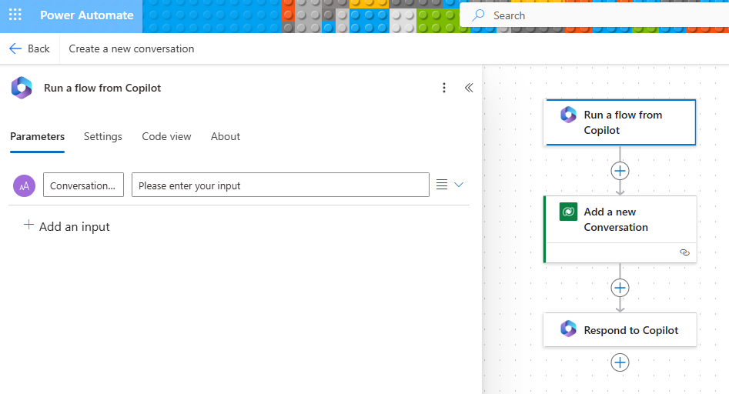

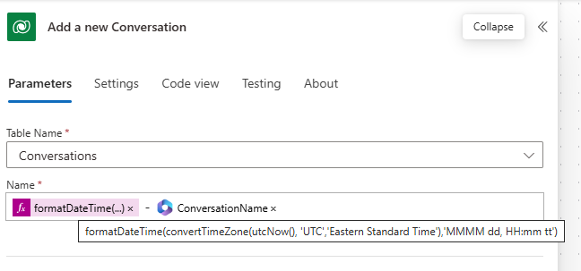

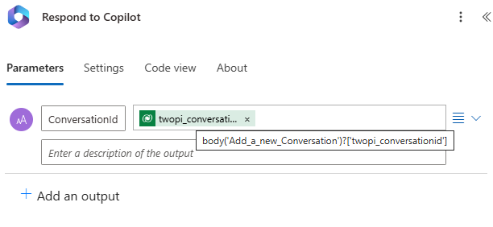

The fallback topic
The fallback topic triggers when the orchestration engine has detected nothing. Counterintuitively in this solution it is our core topic.
As we have not created any custom topic yet, all we are doing is forcing the user to keep looping over and over in the fallback topic, building the conversation recursively.
All we do is save the last user message in our Conversation table, call the assistant API, save the assistant answer and display it in the chat and it keeps going.
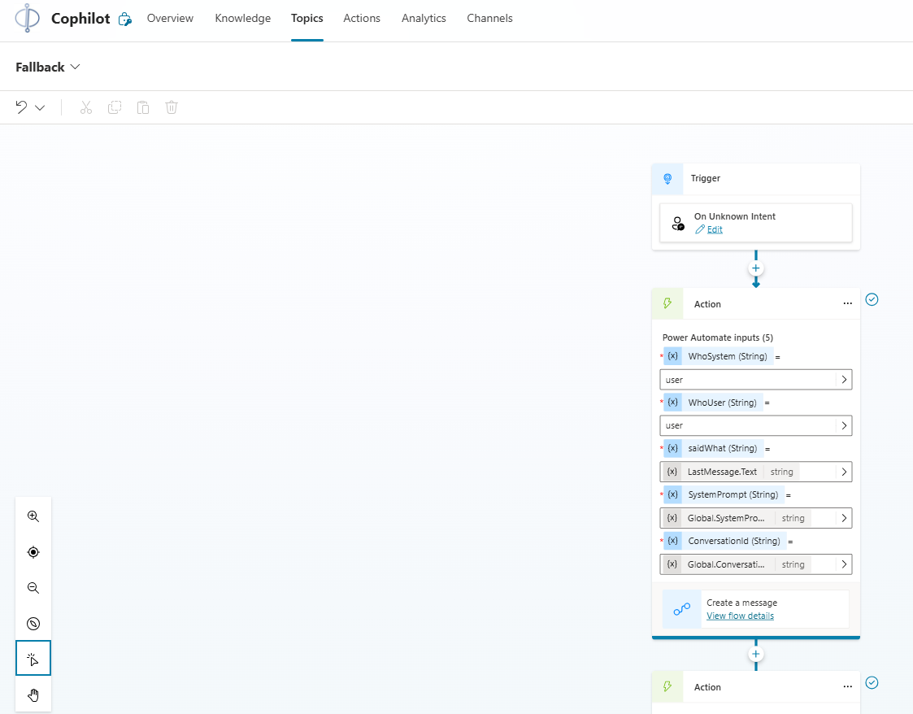
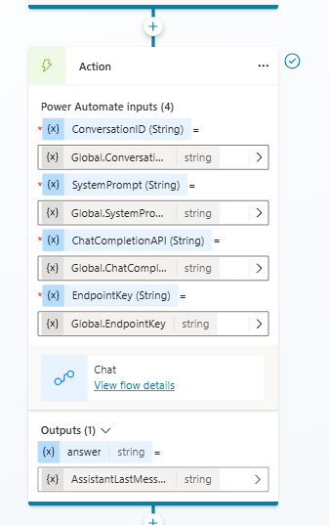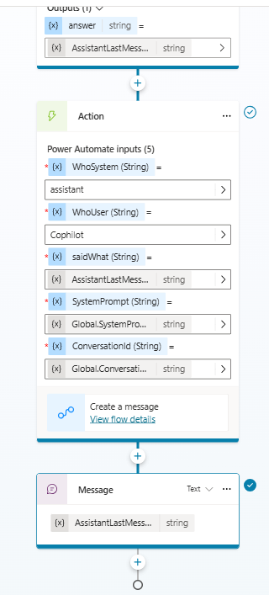

Calling Power Automate to create a new user or assistant Message
All we are doing in this flow is saving the last user or assistant message in our Conversation and Message tables.
- WhoSystem is either user or assistant
- WhoUser is the actual name of the user or the assistant
- saidWhat is what the user or assistant said
- SystemPrompt is the log of the system prompt if it is an assistant message
- ConversationId is the internal dataverse record Id of our current conversation
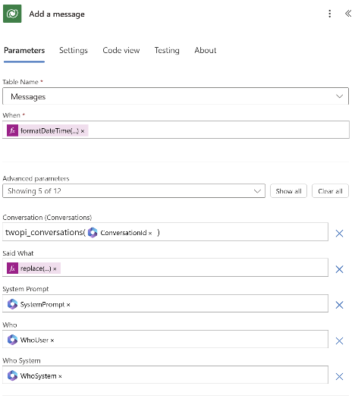
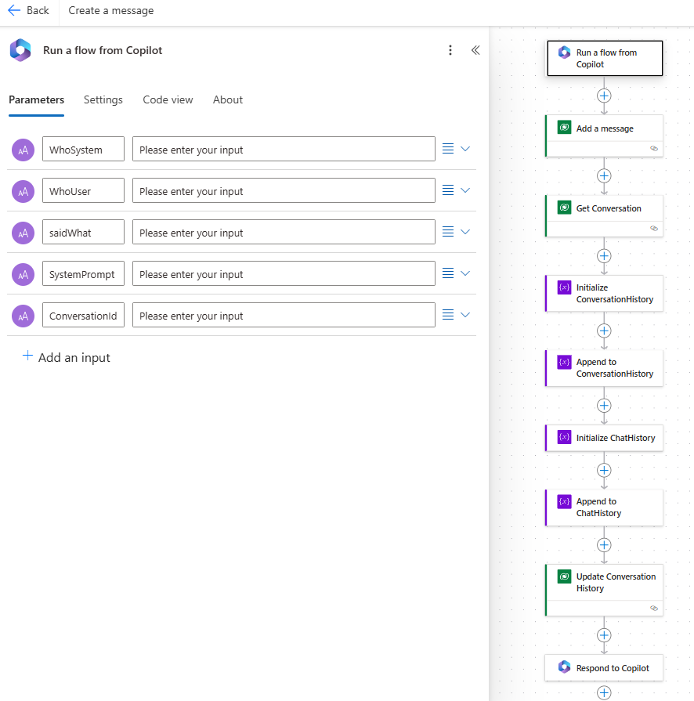
Here are the formulas I used when adding a record to the Message table:
- When is the ‘name’ of the record that we will sort the messages by
formatDateTime(convertTimeZone(utcNow(),'UTC','Eastern Standard Time'),'HH:mm tt ss')
- Said What is what the user or assistant just said
replace(triggerBody()?['text_2'],'"','')

The first important thing to notice here is how to save a look up field in Power Automate with a Dataverse action. Make sure to use the internal name of the table you are pointing to, including the ‘s’ and in parathesis the record id (here ConversationId)
Replace function is just a ‘trick’. We are in effect removing all the double quote from the message as the parseJSON action in Power Automate doesn’t understand easily double quote (there must be a way to figure it out, maybe in more pro code fashion, but have not figure it out yet).

Once we saved the message table, the rest of the flow is building the JSON message table and the user readable conversation history.

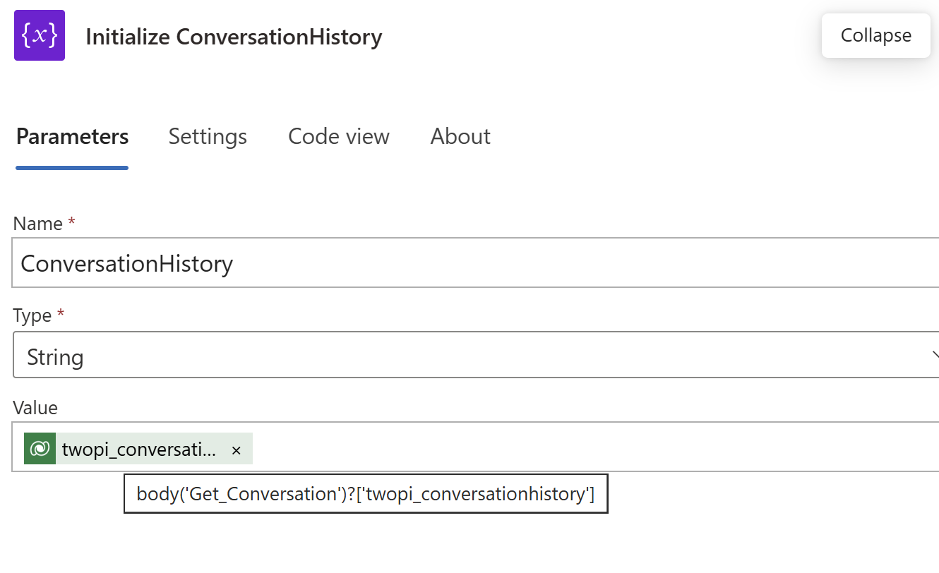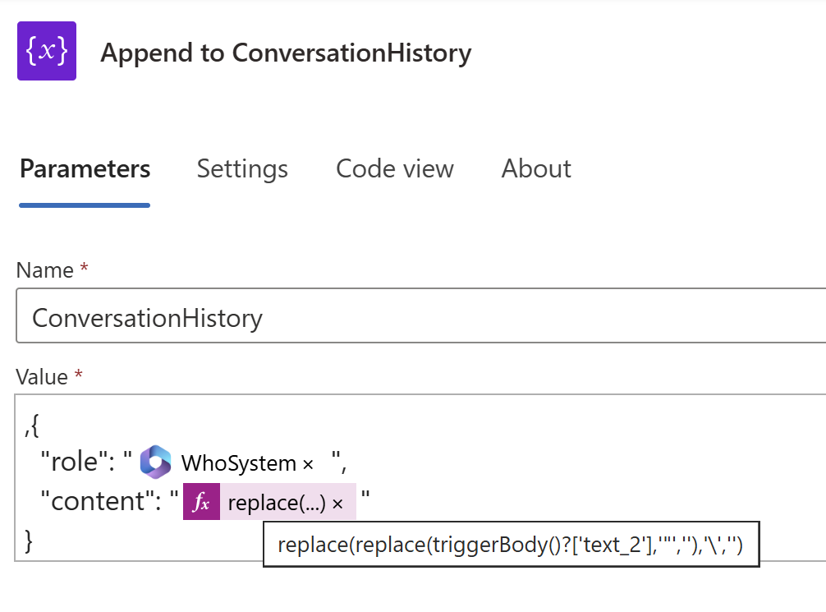
Here is the ‘replace’ PowerFx formula :
replace(replace(triggerBody()?['text_2'],'"',''),'\','')

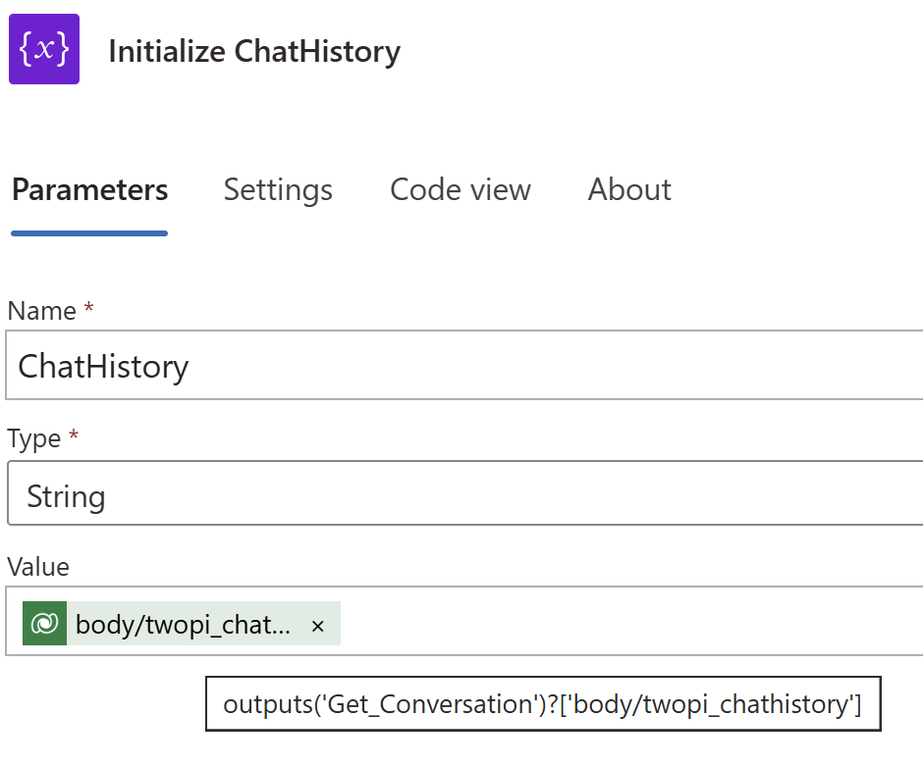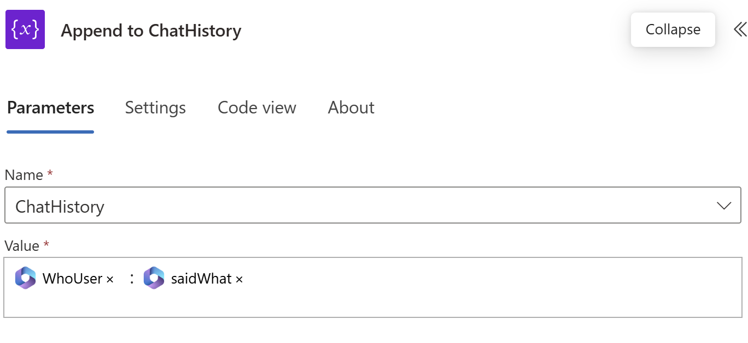

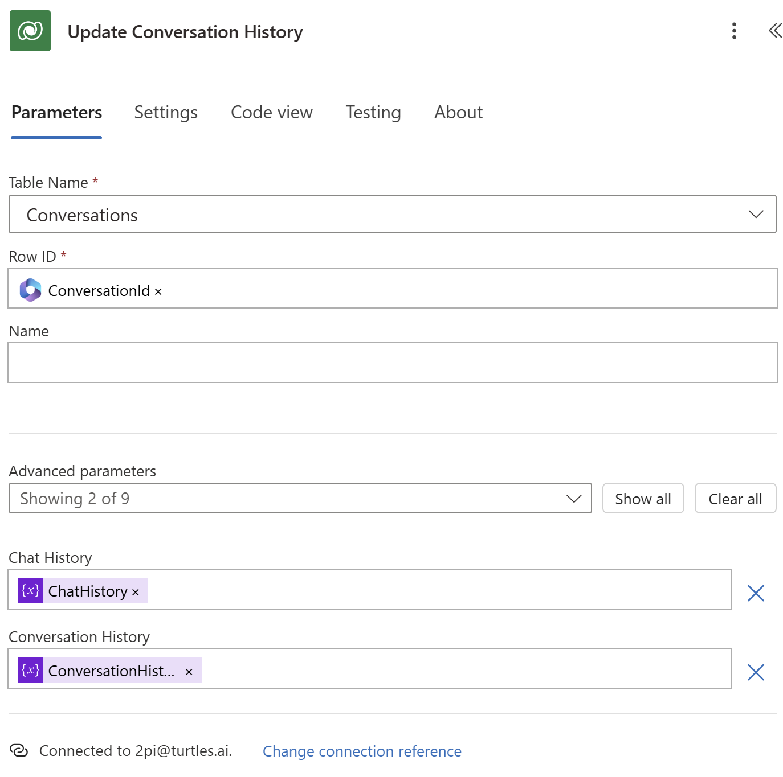

Calling Power Automate to chat with the model
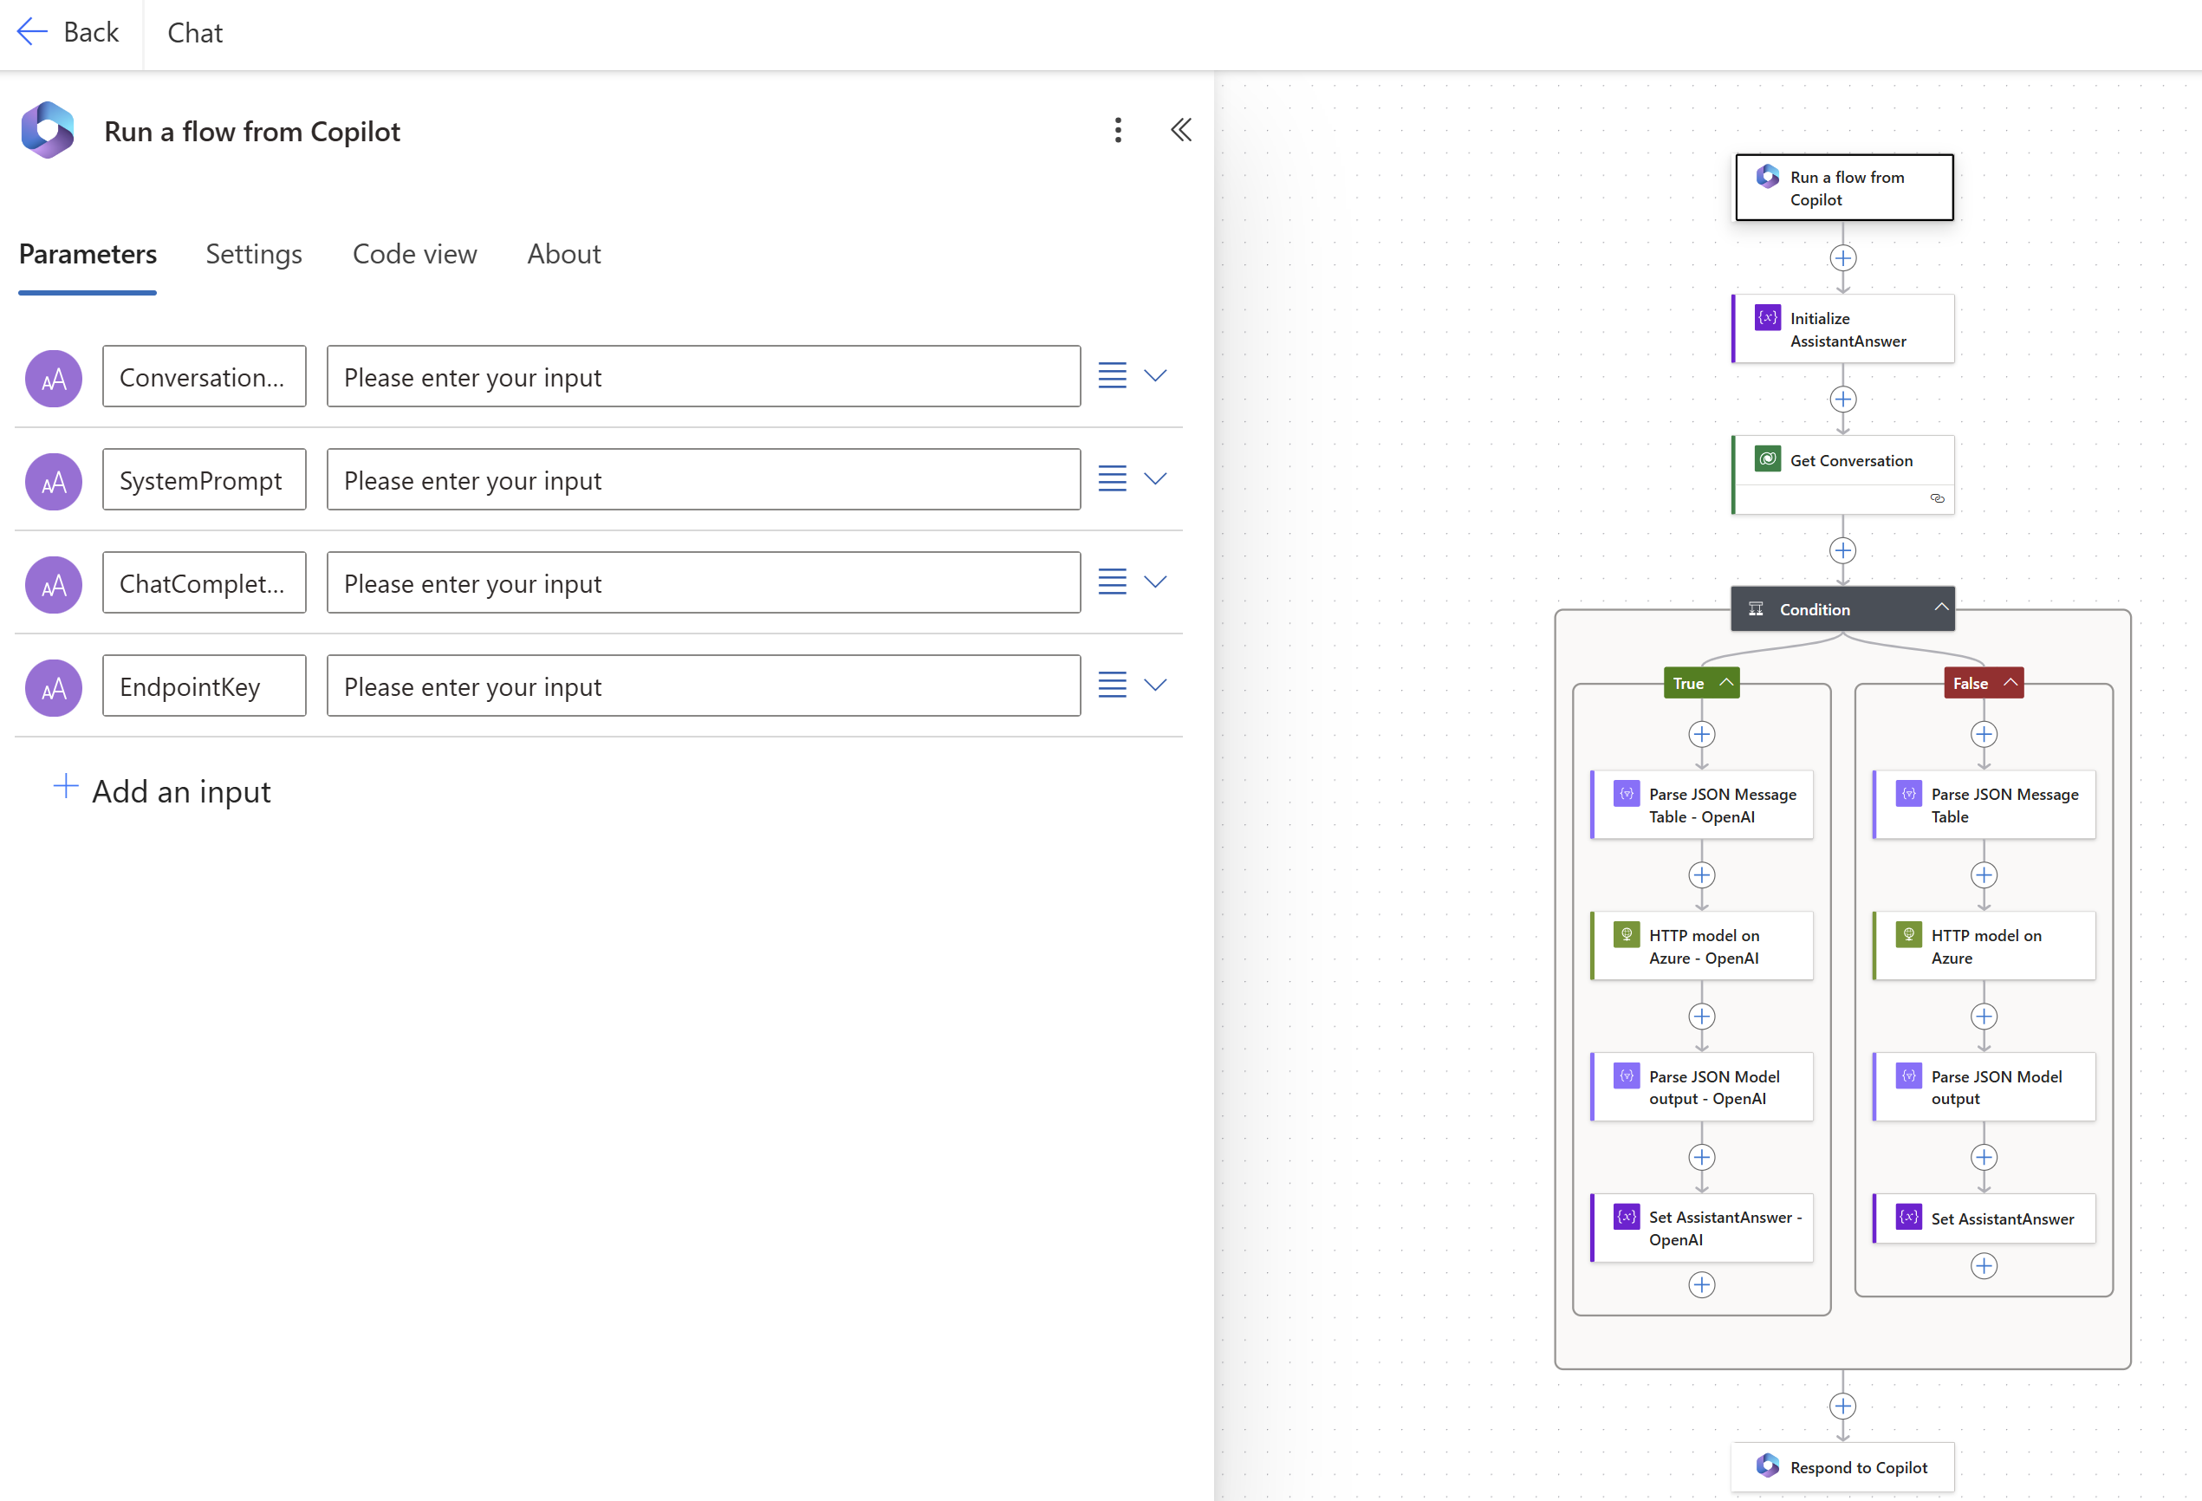

We use this flow to call whatever Gen AI problem. We use a condition to fork depending if the model is openai or not. The API call to those models are often the same, the headers can be different and not everyone understand the concept of system prompt.

Below is the “openai” detail flow. For Phi 3 and Llama 3.1 use Bearer authentication and switch the ‘system’ role to a ‘user’ role. We add the system prompt and parse our JSON message table, ready to be send to the model.
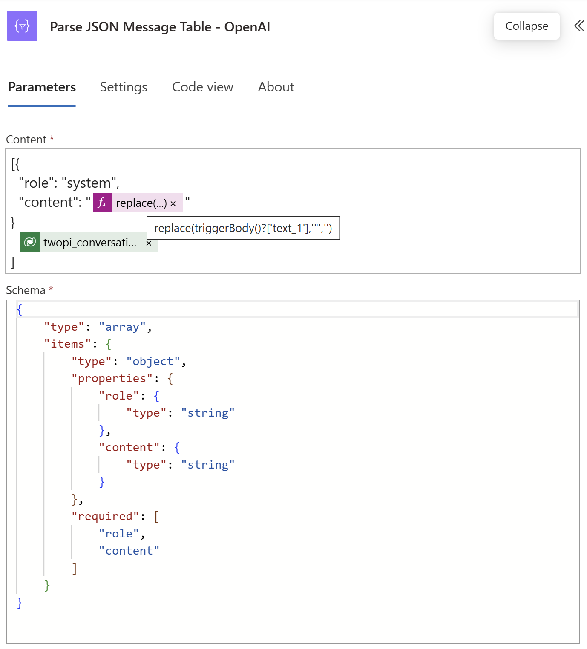
Here is the ‘replace’ formula:
replace(triggerBody()?['text_1'],'"','')
Here is the Schema:
{
"type": "array",
"items": {
"type": "object",
"properties": {
"role": {
"type": "string"
},
"content": {
"type": "string"
}
},
"required": [
"role",
"content"
]
}
}

Calling Azure AI model from Power Automate
Here we are using the Power Automate HTTP connector. We are prototyping.
Should the solution take off, it is good practice to encapsulate the API in a custom connector.
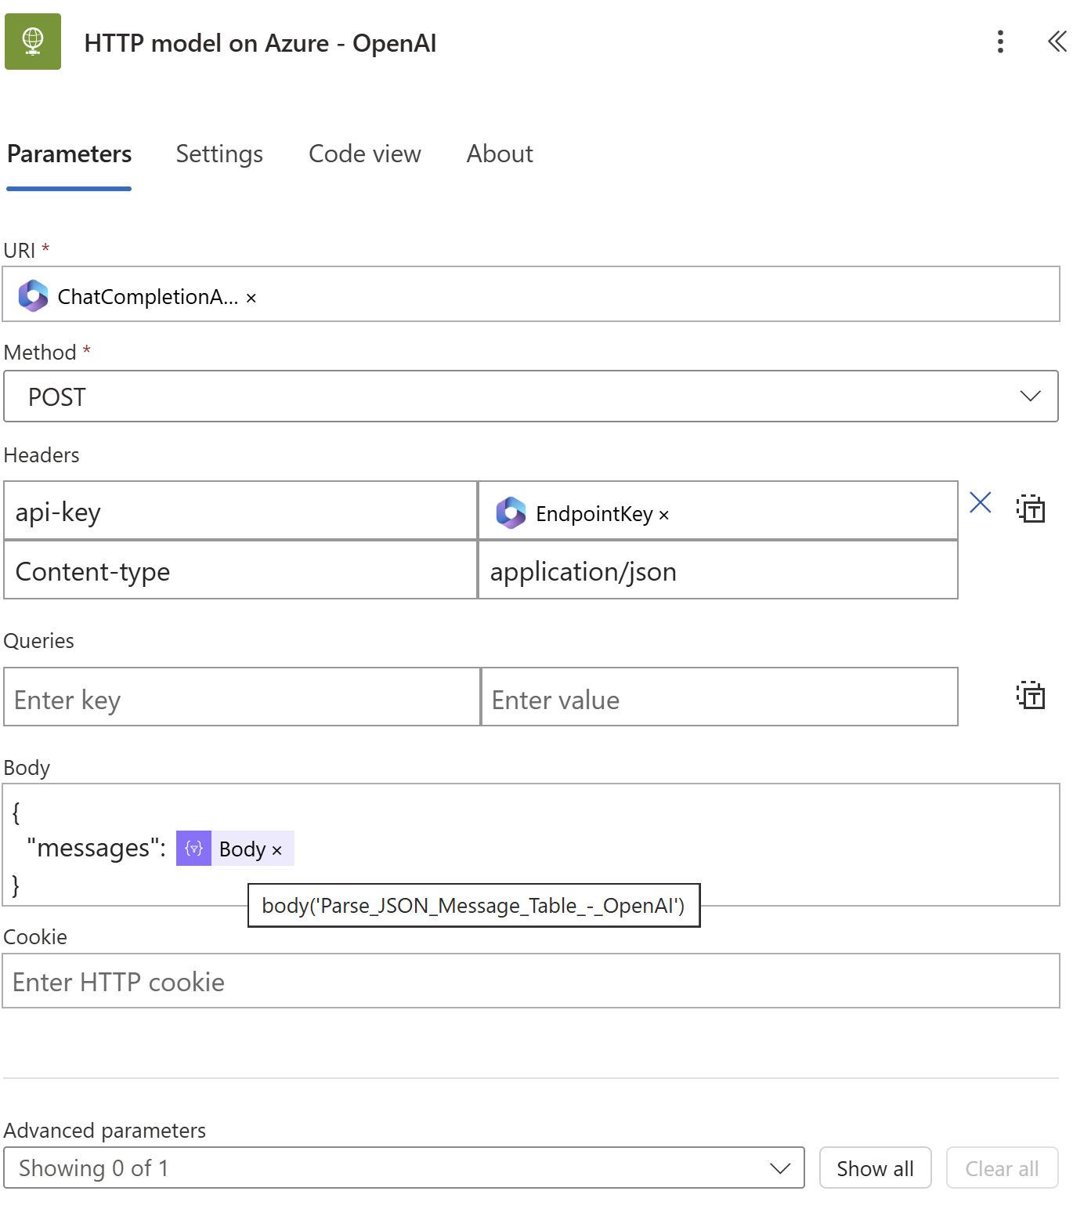

Parsing Azure AI model and the retrieving assistant answer

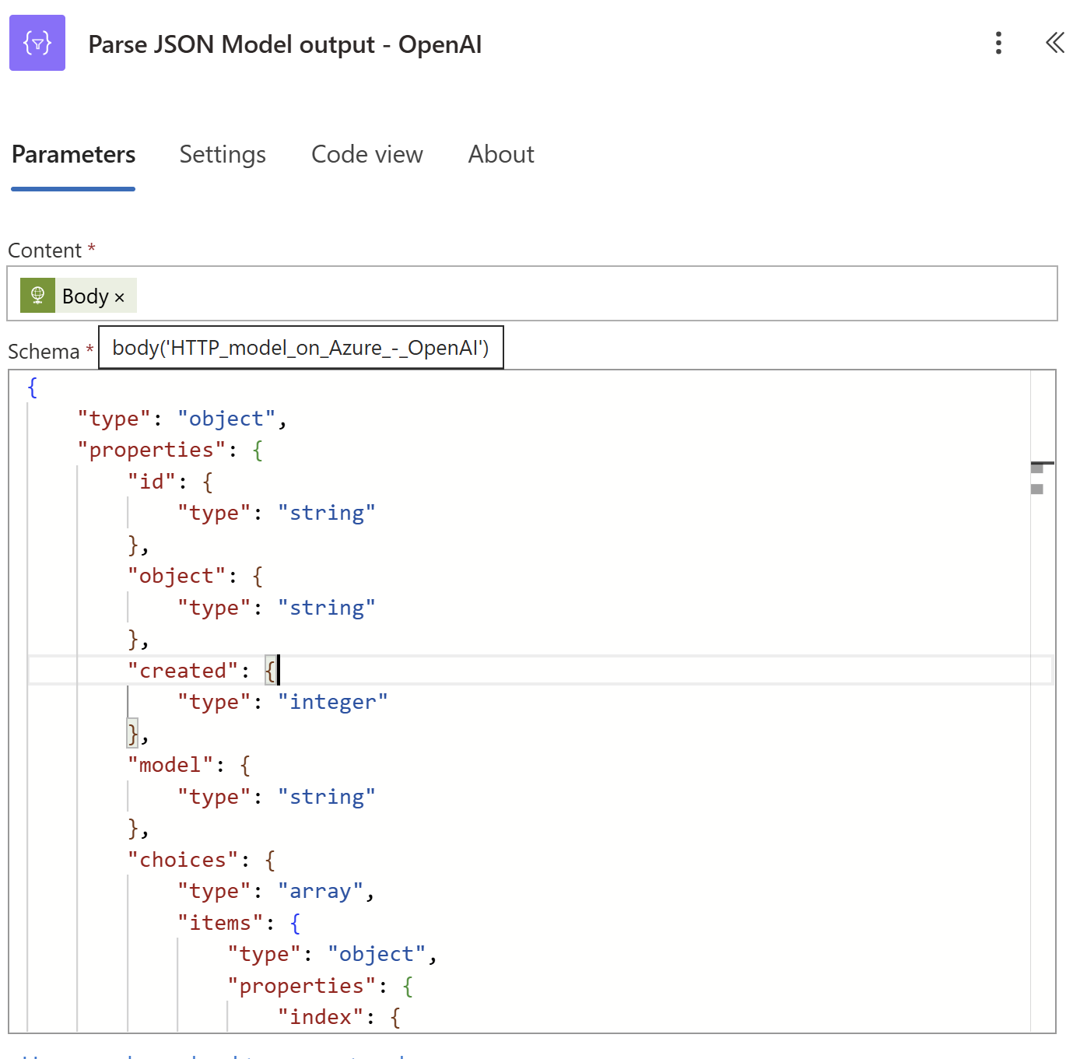

Here is the schema:
{
"type": "object",
"properties": {
"id": {
"type": "string"
},
"object": {
"type": "string"
},
"created": {
"type": "integer"
},
"model": {
"type": "string"
},
"choices": {
"type": "array",
"items": {
"type": "object",
"properties": {
"index": {
"type": "integer"
},
"message": {
"type": "object",
"properties": {
"role": {
"type": "string"
},
"content": {
"type": "string"
},
"tool_calls": {
"type": "array"
}
}
},
"finish_reason": {
"type": "string"
}
},
"required": [
"index",
"message",
"finish_reason"
]
}
},
"usage": {
"type": "object",
"properties": {
"prompt_tokens": {
"type": "integer"
},
"total_tokens": {
"type": "integer"
},
"completion_tokens": {
"type": "integer"
}
}
}
}
}

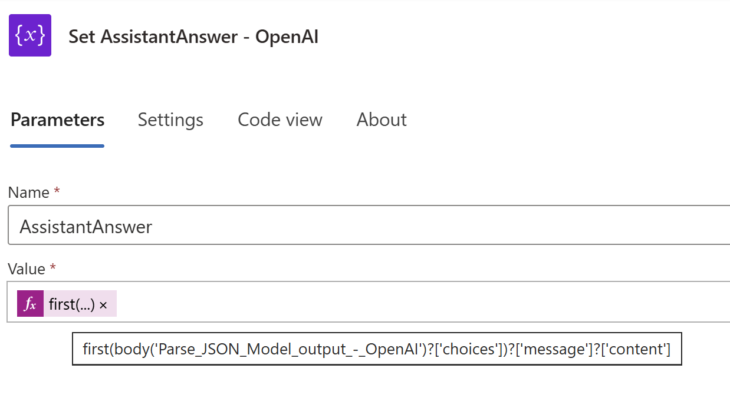
Here is the PowerFx formula:
first(body('Parse_JSON_Model_output_-_OpenAI')?['choices'])?['message']?['content']

Finally respond to Copilot Studio with the assistant answer.
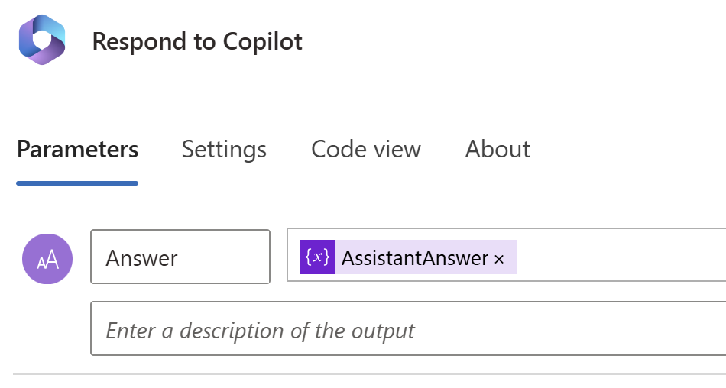

Adding custom topics
At this stage we essentially have created a bot that just keeps building a conversation until we create a new conversation.

New conversation
The first custom topic we author is to reset the conversation. I like to think of it as the clear chat button in ChatGPT.
It is good Conversation UX practice to reflect with the user the topic has been understood. We display an acknowledgement message and redirect the user to our Reset Conversation.
We are back on our feet.
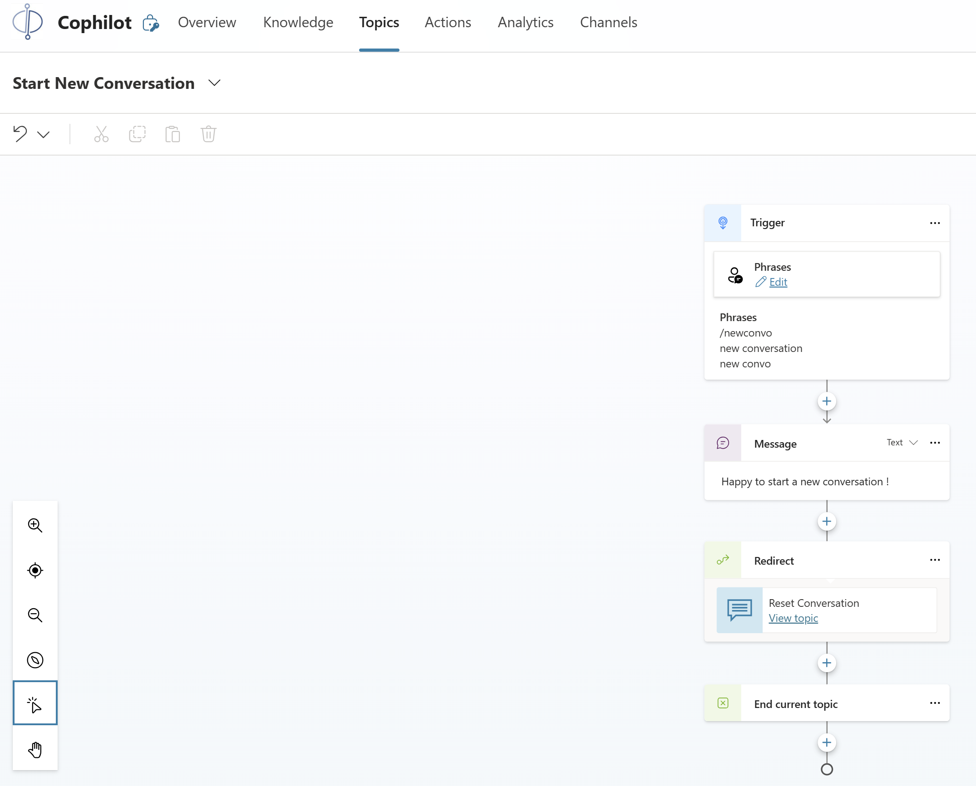

Switching models
In the same spirit we create two topics to switch between Llama 3.1 and Phi 3.
We are setting the model endpoint and keys variables to Llama 3.1 using our environment variables.
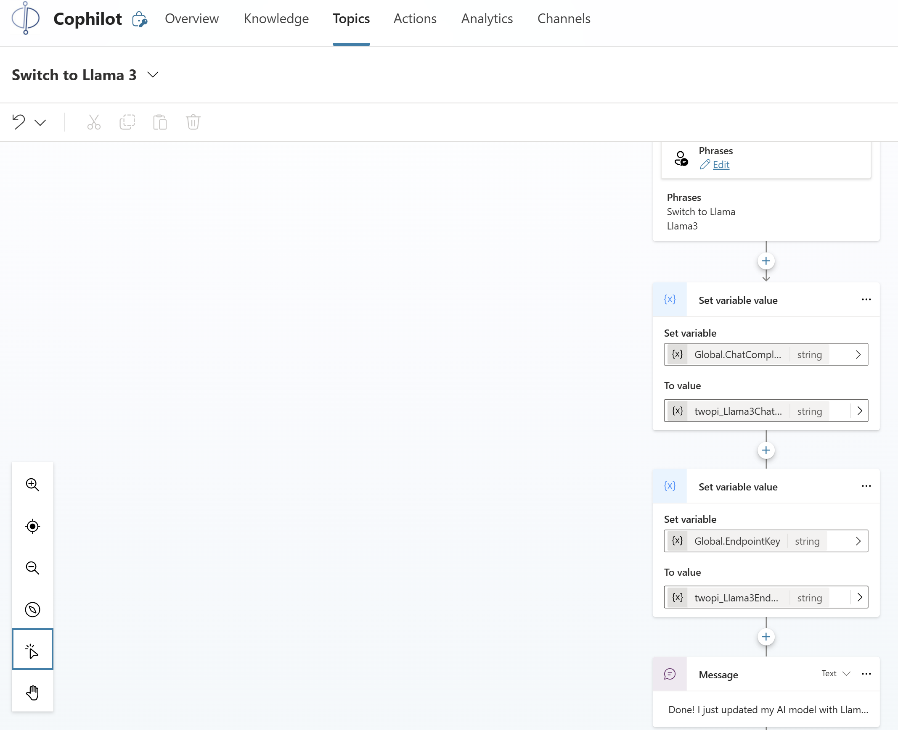

Viewing and updating dynamically the system prompt
As we are at it, we offer the end user to view and update the system prompt in the middle of the conversation, updating the system prompt variable.
